**Smart Planter Parts List:**

1. Microprocessor: Arduino Nano

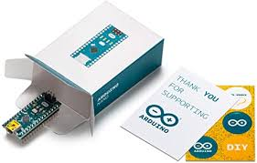

2. LCD display: 128x64 LCD display (can use any you’d just have to change the design)

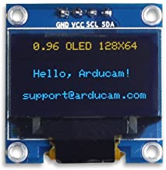

3. Capacitive Soil Sensor

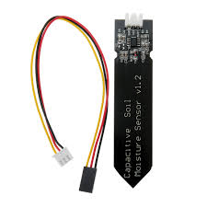

4. Power Supply: (I used a 9 V battery but an optimization of the power supply is required as for this design I didn’t prioritize power supply)

a. Battery Connection

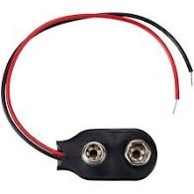

b. 9 V battery

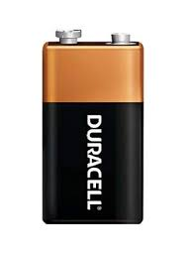

5. Switch: (Used to turn the system on and off, size of the switch will differ so the 3D design will likely need to be updated)

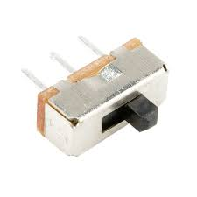

6. Button: (Used to access secret message, must be customized)

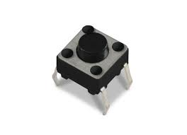

7. Resistors: (Design requires three resistors, one to keep the button grounded until pressed, and two for the LCD display)

8. Wires to connect to LCD display, others needed if not using PCB